
ECHELON SOLUTIONS
consulting
sales
staffing
support
ECHELON SOLUTIONS

ECHELON SOLUTIONS
A 104,JALKIRTI,
JAYRAJ NAGAR,
BORIVLI(W),
MUMBAI 400091
+912228997091 ph
www.echelon-solutions.com
simplifying IT

e-Docs
Electronic Document Management System

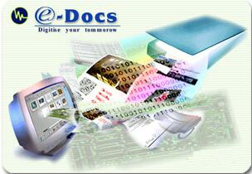

Easy and Flexible solution for managing and sharing information

Introduction:

Welcome to e-Docs Document Management System, the most flexible document management and archiving software. Storing and retrieving documents has, up until now, been an onerous task. e-Docs Document Management System solves the problems faced when using a manual document filing system by:

- Freeing costly storage space.
- Providing extensive security measures to keep confidential documents safe from prying eyes.
- Combining both computer generated and paper documents in an effective document storage and retrieval system.
- Allowing users to revise, create versions, annotate and share documents with a workgroup.
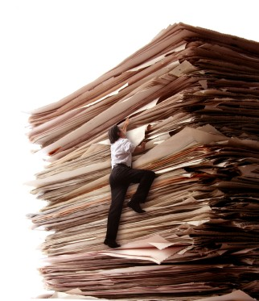
- Providing full text indexing for complete retrieval of related documents based on a query by word or phrase.
- Eliminating time-consuming physical searches due to misfile or lost documents.
- Protect documents from natural calamities (Rain, Fire, Age..)

e-Docs is modeled on the same physical dynamics you use in your present office environment. Storing documents is done in a Cabinet. Cabinet contains Folders. Folder contains Sub-Folders, which can hold Documents. Documents contain pages.

This helps you to easily reproduce your existing filing system structure in e-Docs. Or you might want to take advantage of this opportunity to update and improve your filing system. With e-Docs Document Management System flexibility is inbuilt to work more productively.

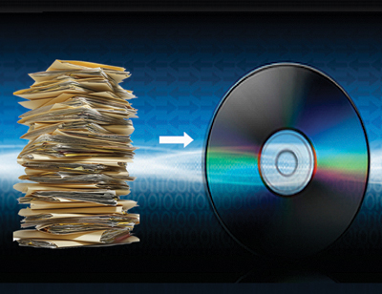
e-Docs information management and sharing solution that fits like a glove into your current work environment. e-Docs runs on your existing hardware, installs easily, and requires little or no training or internal support.

e-Docs lets team members use your corporate intranet or extranet to set up a virtual information sharing environment. Here, users can easily post, retrieve and search for information that resides in familiar nested folders. And they can adapt e-Docs to suit the specific needs of any workgroup or project. e-Docs gives you instant and controlled access to information. Read and write permission rights are granted and maintained by the workgroup itself.

Features of e-Docs:

This latest version of e-Docs includes new features that give workgroup members even more power and control over creating and distributing their own work. Within minutes of installing e-Docs, users can:

Create user accounts, permission groups, and shared workspaces.
It’s fast and easy to set up a virtual workspace that transcends the usual organizational and geographic boundaries.

Work easily with all types of documents.
You can post text, graphics, video and other files in e-Docs collections, which are organized and displayed in familiar nested folders.

Documents can also appear in multiple collections at the same time.

Assign custom properties and attributes to e-Docs objects.
This gives users a great deal of flexibility in categorizing content for their particular systems. It makes it easy to search for and retrieve digitally stored information such as image and video files.

Find documents fast.
A powerful, full-text search engine delivers quick search results. And thanks to the incremental database indexing, documents are always current.


Navigate easily through directories.

Information appears in familiar nested folders, making files easy to find.
- Objects (collections, documents, bulletin boards, etc.) can have long descriptive names, brief summary fields and abstracts for easy browsing.
- Objects can appear in multiple locations for easier file organization.
- It’s quick and easy to browse for information using a “bird’s eye view” of e-Docs collections that displays an index of the major folders in a collection.

Search Effortlessly

Use the intuitive search engine to look for content created by most standard desktop applications.
• See which files most closely match your search criteria.
• Always get the latest version, as all documents and other objects are indexed
incrementally. No more waiting for overnight updates!
• Easily search and retrieve documents by text, attribute or both.
• See at a glance what’s been recently added or modified in any e-Docs collection.

Customize properties to suit your business needs.
The new custom properties feature allows you to assign new properties to existing e-Docs objects through the administration tool.
• Supports string, Boolean, Date, integer and floating point formats.

• Fully indexed and searchable.

Manage multiple revisions.
Keep the most recent version or maintain a version history.
• Track revisions and keep a history of them.
• Lock documents to prevent simultaneous updates.

Keep information secure.
Manage content security by ownership and read/write permissions.
- Assign individual read/write permissions to any object.
It’s easy to create user groups to maintain and alter permissions.
- Users who don’t have viewing permission for any object never see that object. They will not be aware that it exists.

Easily share many different types of files.
It’s easy to post and retrieve text documents; graphics, audio and video files; and compiled programs.
• Search, manage, access and view documents from any platform.

Enjoy a convenient administration tool.
e-Docs minimizes system administration. And there is a full set of administrator functions to make the job go quickly and smoothly.
- Track activity on the e-Docs server to determine who did what, when and how often
- Error and activity log files are stored in CSV format for easy importing into Excel or other applications.
- Customize the interface to suit the needs of individual workgroups
- Manage user passwords and accounts

Types of documents which can be stored
e-Docs allows you to store many different types of document within a folder. You can store scanned documents along with computer generated text documents, spreadsheets, images, multimedia files, or sound files.


Security
In the normal course of business you often come upon the need to store certain documents securely away from prying eyes or mischief. E-Docs is equipped to deal with that need by allowing you to choose who will have access to a document, folder sub-folder, or a cabinet. You may also set security for user rights to for creating, modifying, deleting, moving/transferring or viewing Cabinets, Folders, Sub-folders, documents or pages. Application default properties can be secured by the use of an administrator password that will disable user’s ability to make changes to system defaults.

Workflow*
e-Docs allows for a workflow system that can be created with the use of the In Box. Documents can be routed electronically to desired users who can see their assigned tasks in their InBox. Hot linking allows the user to select the document directly from the InBox allowing them to work on it instantly. Users can attach their comments to the documents when they are in review.

Annotation
This tool allows you to annotate (comment) a document in various ways while keeping the integrity of the original document intact.

Document Viewing
Documents are viewed using two types of document viewers. The Image Viewer is used to view documents that are image files or are scanned into the database. The OLE Document Viewer is used to view documents that have been generated by an OLE compliant program such as Microsoft Word, Excel, or Corel WordPerfect etc.

Versioning
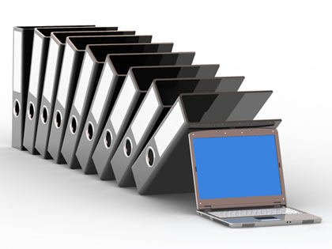
This feature of e-Docs allows you to edit documents while keeping the integrity of the original document. E-Docs will automatically save any changes in an edited document as a numbered version of the original. A Check out/Check in mechanism ensures document integrity as well as version control so that only the latest documents are available. Older versions can be retrieved if desired for view purposes only. This helps the entire organization since everybody sees only the latest copies of documents thus eliminating time, money & business integrity loss arising out of referring to wrong/old versions.

Moving or Copying Documents
Moving or copying documents is done by the normal Windows convention of dragging and dropping an item (Cabinet, Folder, Sub-Folder or Document) to a new location. You may copy and paste or move a single document or selected group of documents. You may also use your right click menu to copy and paste or move the document or selected group of documents anywhere in e-Docs.

Deleting Documents
Deleting documents uses the normal Windows convention of the Recycle Bin. Merely drag the item you wish to delete to the Recycle Bin and it will remove the document from its present folder to be discarded when you decide to empty the Recycle Bin.

Retrieving Documents
To quickly retrieve documents use the Search Engine located on the Toolbar or the right mouse button menu. That will bring up the Search Engine Dialogue Box.

e-Docs provides a powerful and intuitive Search. You can search for Documents and Folders across the system by using Index-based search or the Keyword-based search. Or you may specify both queries simultaneously, in which case a result satisfying both the queries / either of the queries will be displayed.

Documents within the system can be searched by choosing the “Document Search” option from the menu. For searching the Pages within the system, choose “Page Search” option.

User Definable Indexing System
You can create index fields, as you need. e-Docs allows for user Definable Index Fields. These fields will allow you to configure e-Docs precisely to your needs, allowing for quicker retrieval of documents or Pages.

Linking Documents
Show links of a Document facility shows all the links of the current document to different Folders

e-Docs Document Log
Trace Document Log facility shows all modifications made to a Document by different users of e-Docs

Backup
Volume Backup facility allows backup of a Volume (onto a CD-ROM) or moving a Volume from one PC to another

Electronic Mail Messages (iTrack Vault)
If you use any MAPI compliant mailing software like Microsoft Exchange™, you can directly access the electronic mail Inbox from within e-Docs. You can drag-n-drop received & sent mails into Documents of e-Docs as a Part of our Enterprise Suite of Email Archival.

Make e-Docs a Part of your Office Efficiency Tools !!

